**Chapter 5**

**Sequences and Series**

**5.1 Sequences**

**Section Exercises**

**Find the first six terms of each of the following sequences, starting with **

1.  for 

Answer:  if  is odd and  if  is even

3.  and  for 

Answer: 

5. Find an explicit formula for  where  and  for 

Answer: 

7. Find a formula  for the  term of the arithmetic sequence whose first term is  such that  for 

Answer: 

9. Find a formula  for the  term of the geometric sequence whose first term is  such that  for 

Answer: 

11. Find an explicit formula for the  term of the sequence satisfying  and  for 

Answer: 

**Find a formula for the general term  of each of the following sequences.**

13. 

Answer: 

**Find a function  that identifies the  term  of the following recursively defined sequences, as **

15.  and  for 

Answer: 

17.  and  for 

Answer: 

**Plot the first  terms of each sequence. State whether the graphical evidence suggests that the sequence converges or diverges.**

19. **[T]**   and for   

Answer: Terms oscillate above and below  and appear to converge to 

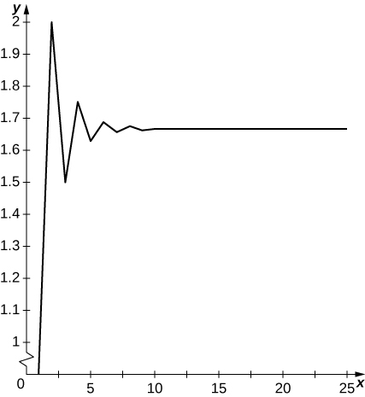

21. **[T]**   and for   

Answer: Terms oscillate above and below  and appear to converge to a limit.

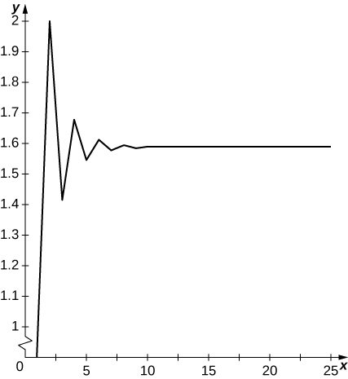

**Suppose that   and  for all  Evaluate each of the following limits, or state that the limit does not exist, or state that there is not enough information to determine whether the limit exists.**

23. 

Answer: 

25. 

Answer: 

**Find the limit of each of the following sequences, using L’Hôpital’s rule when appropriate.**

27. 

Answer:

29. 

Answer: 

**For each of the following sequences, whose  terms are indicated, state whether the sequence is bounded and whether it is eventually monotone, increasing, or decreasing.**

31.  

Answer: bounded, decreasing for 

33. 

Answer: bounded, not monotone

35.  

Answer: bounded, decreasing

37. 

Answer: not monotone, not bounded

39. Determine whether the sequence defined as follows has a limit. If it does, find the limit   

Answer:  is decreasing and bounded below by  The limit  must satisfy  so  independent of the initial value.

**Use the Squeeze Theorem to find the limit of each of the following sequences.**

41. 

Answer: 

43. 

Answer: : and  so 

**For the following sequences, plot the first  terms of the sequence and state whether the graphical evidence suggests that the sequence converges or diverges.**

45. **[T]** 

Answer: Graph oscillates and suggests no limit.

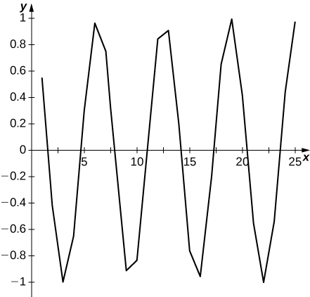

**Determine the limit of the sequence or show that the sequence diverges. If it converges, find its limit.**

47. 

Answer:  and  so 

49. 

Answer: Since  one has  as 

51. 

Answer:  and  as  so  as 

53. 

Answer:  In particular,  so  as 

**Newton’s method seeks to approximate a solution  that starts with an initial approximation  and successively defines a sequence  For the given choice of  and  write out the formula for  If the sequence appears to converge, give an exact formula for the solution  then identify the limit  accurate to four decimal places and the smallest  such that  agrees with  up to four decimal places.**

55. **[T]**  

Answer:    

57. **[T]** ,

Answer:   

59. [**T]** A lake initially contains  fish. Suppose that in the absence of predators or other causes of removal, the fish population increases by  each month. However, factoring in all causes,  fish are lost each month.

* 1. Explain why the fish population after  months is modeled by  with 
  2. How many fish will be in the pond after one year?

Answer: a. Without losses, the population would obey  The subtraction of  accounts for fish losses. b. After  months, we have 

61. [**T]** A student takes out a college loan of  at an annual percentage rate of compounded monthly.

* 1. If the student makes payments of  per month, how much does the student owe after  months?
  2. After how many months will the loan be paid off?

Answer: a. The student owes  after  months. b. The loan will be paid in full after  months or eleven and a half years

63. **[T]** The binary representation  of a number  between  and  can be defined as follows. Let  if  and  if  Let  Let  if  and  if  Let  and in general,  and  if  and  if  Find the binary expansion of 

Answer:    so the pattern repeats, and 

**For the following two exercises, assume that you have access to a computer program or Internet source that can generate a list of zeros and ones of any desired length. Pseudorandom number generators (PRNGs) play an important role in simulating random noise in physical systems by creating sequences of zeros and ones that appear like the result of flipping a coin repeatedly. One of the simplest types of PRNGs recursively defines a random-looking sequence of  integers  by fixing two special integers  and  and letting  be the remainder after dividing  into  then creates a bit sequence of zeros and ones whose  term  is equal to one if  is odd and equal to zero if  is even. If the bits  are pseudorandom, then the behavior of their average  should be similar to behavior of averages of truly randomly generated bits.**

65. [**T]** Starting with  and  using ten different starting values of  compute sequences of bits  up to  and compare their averages to ten such sequences generated by a random bit generator.

Answer: For the starting values     the corresponding bit averages calculated by the method indicated are          and Here is an example of ten corresponding averages of strings of  bits generated by a random number generator:           There is no real pattern in either type of average. The random-number-generated averages range between  and  a range of whereas the calculated PRNG bit averages range between  and  a range of 

**Student Project**

**Fibonacci Numbers**

1. Write out the first twenty Fibonacci numbers.

Answer: 0, 1, 1, 2, 3, 5, 8, 13, 21, 34, 55, 89, 144, 233, 377, 610, 987, 1597, 2584, 4181

3. Use the answer in 2 c. to show that 

Answer:



We notice that the denominator is a geometric series with ratio  Therefore, the denominator can be rewritten as



Therefore, we can write



is a geometric series with ratio



Since 



This file is copyright 2016, Rice University. All Rights Reserved.